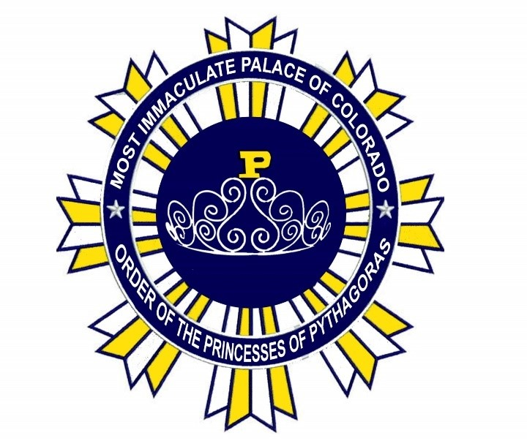
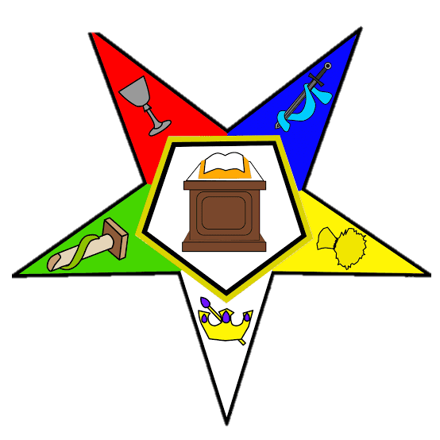
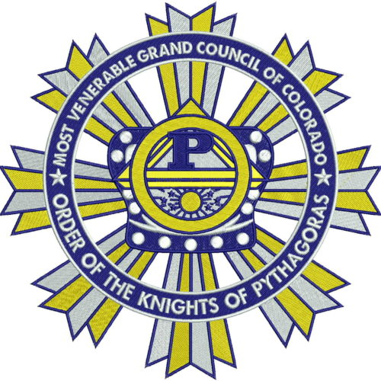
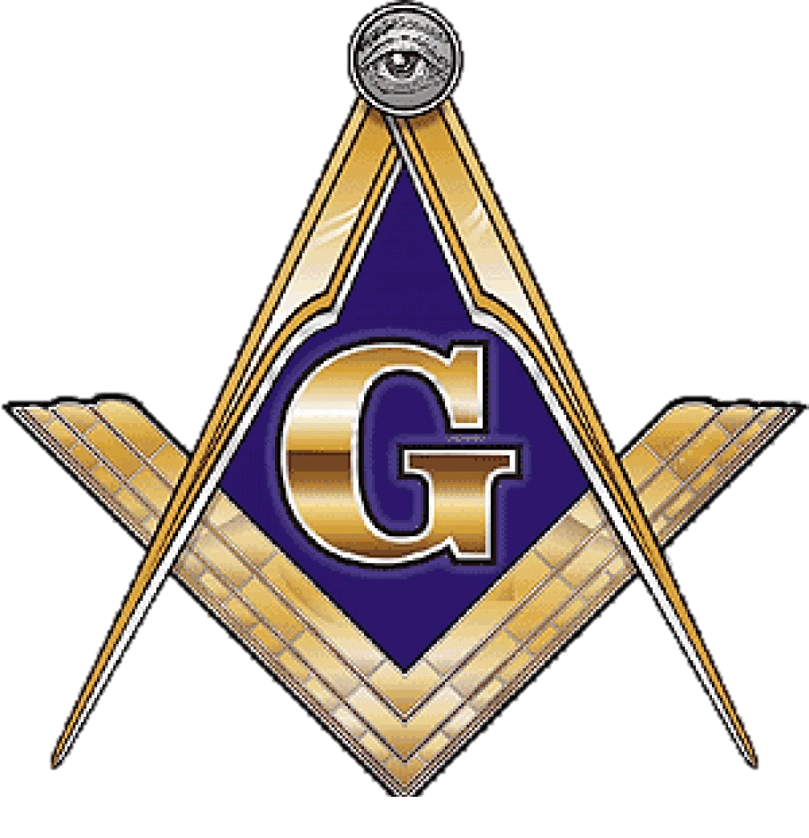

THE MOST VENERABLE RUSSELL E. CREIGHTON SUPREME COUNCIL
ORDER OF THE KNIGHTS OF PYTHAGORAS
OF COLORADO & JURISDICTIONS
SPONSORED BY THE MOST WORSHIPFUL PRINCE HALL GRAND LODGE OF
COLORADO & JURISDICTIONS INC
&
IMMACULATE PALACE OF COLORADO
ORDER OF THE PRINCESSES OF PYTHAGORAS
SPONSORED BY THE COLUMBINE GRAND CHAPTER ORDER OF THE EASTERN STAR COLORADO AND JURISDICTION INC

February 8, 2026

To: The Most Worshipful Grand Master Jeffery O. Alexander, Right Worshipful Deputy Grand Master Felix A. Barbain Jr., Right Worshipful Senior Grand Warden Stanley H. Brooks Jr., Right Worshipful Junior Grand Warden Derrick Shaw, Most Worshipful Past Grand Masters, Past Grand Masters, Right Worshipful and Worshipful Grand Lodge Elected and Appointed Officers, Worshipful Masters, Wardens, Past Masters, and Brethren
To: The Grand Worthy Matron Antoinette Dow, Grand Worthy Patron Calvin Somerville, Grand Associate Matron Yasmaine Ford, Grand Associate Patron Sheldon Jackson, Grand Conductress Martha L. Leonard-McClendon, Grand Associate Conductress Crystal M. Parks, Past Grand Worthy Matrons and Patrons, Grand Chapter Elected and Appointed Officers, Worthy Matrons and Patrons. Officers and Members Subordinate Chapters of Columbine Grand Chapter OES. PHA:

SUBJECT: Knights of Pythagoras – Princesses of Pythagoras Information Letter to the Jurisdiction

Greetings to all and with the blessings from the God we serve,

This letter is to provide you with an overview of the following and solicit the committed support of our Jurisdiction, family and friends:
1 – Our history
2 – Our two Youth Groups
a – The Knights of Pythagoras
b – The Princesses of Pythagoras
3 – The role of Masons/Sisters
4 – The role of our Parent Clubs
History of the Pythagoras Youth Clubs
What is the Order of the Knights of Pythagoras
The Order of the Knights of Pythagoras is an organization composed of youths ranging from seven to twenty years (may vary in some states) of age inclusive, working under the sponsorship and personal supervision of Prince Hall Masons, to provide beneficial use of their spare time, worthwhile companions, wholesome, educational environment, and a program aiming to interest and aid youths, in their all-round development.

Who inaugurated this movement and why?
This movement, originally the Chivalric Order of Knight Companions, was commenced by Masons representing The Grand Jurisdiction of Kansas and Colorado, in a conference held November 19th 1938. It was adopted for universal use in the Grand Jurisdiction of Prince Hall Masons dispersed throughout the United States under the name "The Order of the Knights of Pythagoras," at the National Conference of Grand Masters of Prince Hall Masons, under the leadership of Grand Master Amos T. Hall, President, held in Denver, Colorado, May 8-10, 1951. The Princesses of Pythagoras program was brought to fruition during the 2022 Grand Lodge/Chapter Session in Pueblo, Colorado; after inquiries about the need for a Youth Group for the young girls.

The Princesses of Pythagoras was inspired by Sisters and Brothers who had young girls who wanted to be a part of something close to their parents. Inspired by how they saw their parents dress and regale, the comradery, and happiness seen. Young girls were joining the Job’s Daughters and Rainbow Girls of the AF&AM Colorado Grand lodge, some Sisters in the Order actually achieved high positions in those orders. The inquiries about such an Order under the Prince Hall Masonic banner kept increasing. In the Spring of 2022, Past State Director was inspired to create the Princesses of Pythagoras, the work was shared with PM Crystal McAlpin of Lone Star OES Chapter No.1 and Michael Simms, President of the National Knights of Pythagoras initiative under the auspices of the Conference of Grand Masters PHA. The idea was well received, the Order was voted upon favorably during the 2025 Grand Chapter in Cheyenne, Wyoming after a motion from PM Crystal McAlpin OES Chapter No.1, the Grand Chapter Youth Director.

Requirements for the Knights of Pythagoras
The Knights of Pythagoras is open to all young boys ages 5 – 18, exceptions can be made based upon the
recommendation of the parents and their presence at meetings. Child does not have to be related to a
Mason, age, religion, and disability is not a disqualifier. Children are known as Youth Knights, they will be
given life skills, education assistance, lessons on bullying, and suicide prevention to name a few. Field trips,
community service, and other events to provide fun for the youth in their area. Each Area has unique
characteristic and availability to certain vendors, entertainment, and historical landmarks.

Role of Masons
Masons are known as Sir Knights, their roles are to train the Youth Knights on ritualistic work such as opening and closing meetings, how to run meetings, parliamentary procedures, and how to manage and distribute funds in a meeting. Help establish a bond with and between the Youth Knights, and the Princesses, Sir Knights/Queens, and the Parent Club. To provide mentorship and help them in conjunction with the parents to make positive choices in life and become productive members of society. This is not a club to create new Masons, that choice is theirs when they are old enough to understand what that will mean.

Requirements for the Princesses of Pythagoras
The Princesses of Pythagoras is open to all young girls ages 5 – 18, exceptions can be made based upon the
recommendation of the parents and their presence at meetings. Child does not have to be related to a
Sister in the Order of the Eastern Star, age, religion, and disability is not a disqualifier. Children are known
as Princesses, they will be given life skills, education assistance, lessons on bullying, and suicide
prevention to name a few. Field trips, community service, and other events to provide fun for the youth in
their area. Each Area has unique characteristic and availability to certain vendors, entertainment, and
historical landmarks.

Areas and Primary Officers of Knights and Princesses of Pythagoras
1 – The Knights of Pythagoras (Operate in a Council)
a – State Director– Oversees the entire Jurisdiction of Councils, answers to the State Advisor and Most Worshipful Grand Master
b – Area District Directors – Oversees each individual Area, answers to the State Director.
Area 1 – Aurora/Denver, Area 2 – Colorado Springs/Pueblo, Area 3 – Wyoming, Area 4 - Utah
i – Master Knight– Oversees each individual Council, answers to the Area District Director
ii – Senior Knight – Second in charge in the absence of Master Knight, along with other duties, answers to the Area District Director
iii – Junior Knight – Third in charge in the absence of Master and Senior Knights, along with other duties, answers to the Area District Director

2 – The Princesses of Pythagoras (Operate in a Palace)
a – State Directress – Oversees the entire Jurisdiction Palaces, answers to the State Advisor and Grand Worthy Matron
b – Area District Directresses – Oversees each individual Area, answers to the State Directress. Area 1 – Aurora/Denver, Area 2 – Colorado Springs/Pueblo, Area 3 – Wyoming, Area 4 - Utah
i – Lead Princess– Oversees each individual Palace, answers to the Area District Directress
ii – Vice Princess – Second in charge in the absence of Lead Princess, along with other duties, answers to the Area District Directress
iii – Associate Princess – Third in charge in the absence of Lead and Vice Princesses, along with other duties, answers to the Area District Directress

Role of Sisters
Sisters in the Order of the Eastern Star are known as Queens, their roles are to train the Princesses on ritualistic work such as opening and closing meetings, how to run meetings, parliamentary procedures, and how to manage and distribute funds in a meeting. Help establish a bond with and between the Princesses and Youth Knights Sir Knights/Queens, and the Parent Club. To provide mentorship and help them in conjunction with the parents to make positive choices in life and become productive members of society. This is not a club to create new Masons, that choice is theirs when they are old enough to understand what
that will mean.

Role of the Parent Club
The Parent Club are comprised of adults not affiliated with the Masonic Order. They are designed to act as
our booster club to help in the following areas, along with the unique needs of the Areas in which they are
established:
1 – Fundraising
2 – Motivational support
3 – Supervision of their individual children; should the need arise
4 – Chaperones on field trips
5 – Other duties as required

The Parent Club has the following positions along with an earmark in the Area’s bank account in which
they operate:
President – Manager of the Parent Club and Laision to the Area District Deputy
Vice-President – 2nd in charge in the absence of the President
Secretary – Receive monies, issue receipts, and turn money over to the Treasurer
Treasurer – Issues Disbursement vouchers, receives monies, deposit monies received into bank, and keep
accountability of finances at any given time
Chaplain – Performs spiritual services for the Parent club

Cost and requirements to join
1 - Masons $50 and completed background check.
2 - Kids - $25, no background check required.
3 - Parent club - $0 cost and completed background check
4 – Background checks are from https://www.sentrylink.com/. They must be valid for two years, if yours is valid, provide a copy for proof to my email, stanleyrappbrooksjr@gmail.com.

Nelson L. Pierce Crystal McAlpin
NELSON L. PIERCE CRYSTAL MCALPIN
State Director State Directress

Attested By:
Stanley H. Brooks Jr
STANLEY H. BROOKS JR., PSD
State Recorder/Advisor to the State Directress

